# Differentiating

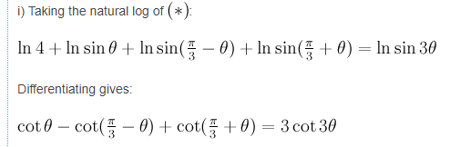

One very clever way of differentiating without using the chain rule is to take natural logs and splitting them up then differentiating.

# Second Derivative Test

The second derivative tells you if, for that point of a graph, it is concave up or down. If the second derivative < 0, it's concave down (meaning there's a relative maximum) and vice versa.

This is because the second derivative is the rate of the change of the gradient. If the gradient is constantly decreasing (becoming less and less positive and then negative). Then it suggests its concave down. If it’s constantly increasing then these points of the graph of the second derivative will be above zero.

<https://www.youtube.com/watch?v=v_Ll05Qsu8U>